**Snake Instructions**

On any screen you may use the ESCAPE key to return back to the main menu which looks like this:

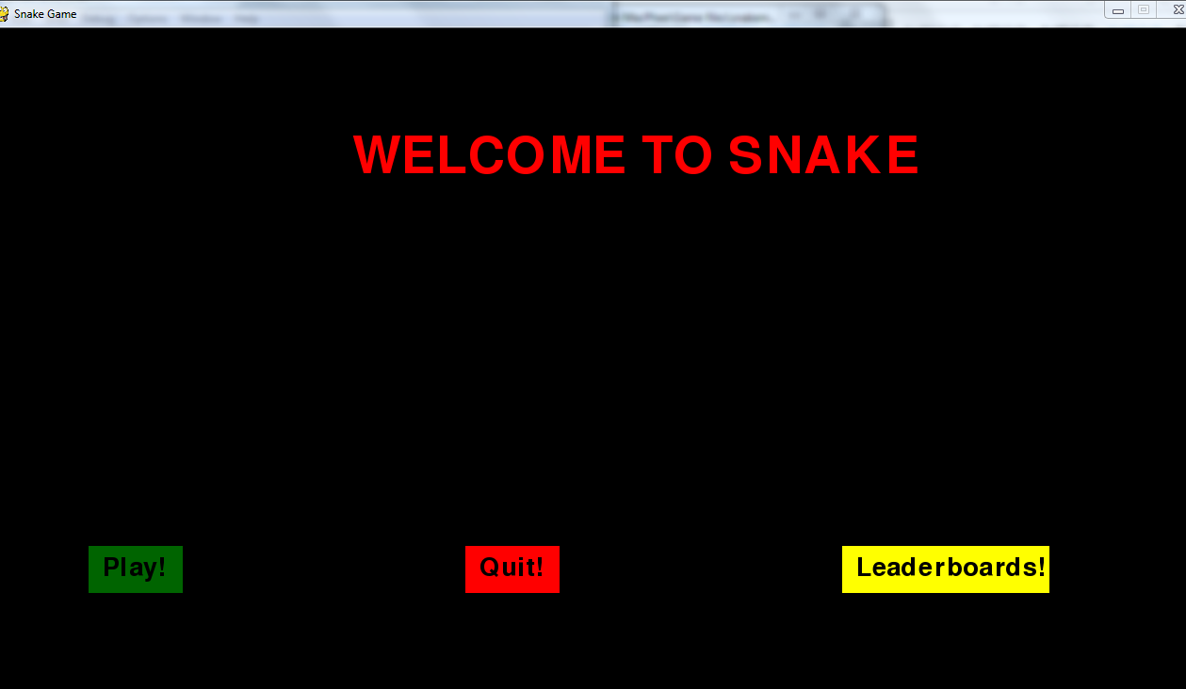

After you click on the GREEN play button you will be taken into the game where the snake will initially be moving towards the right hand side of the screen. Using the arrow keys you will be able to move the snake in the desired direction: UP, DOWN, LEFT, RIGHT.

Pressing the P key will pause the game. To resume just click the green resume button.

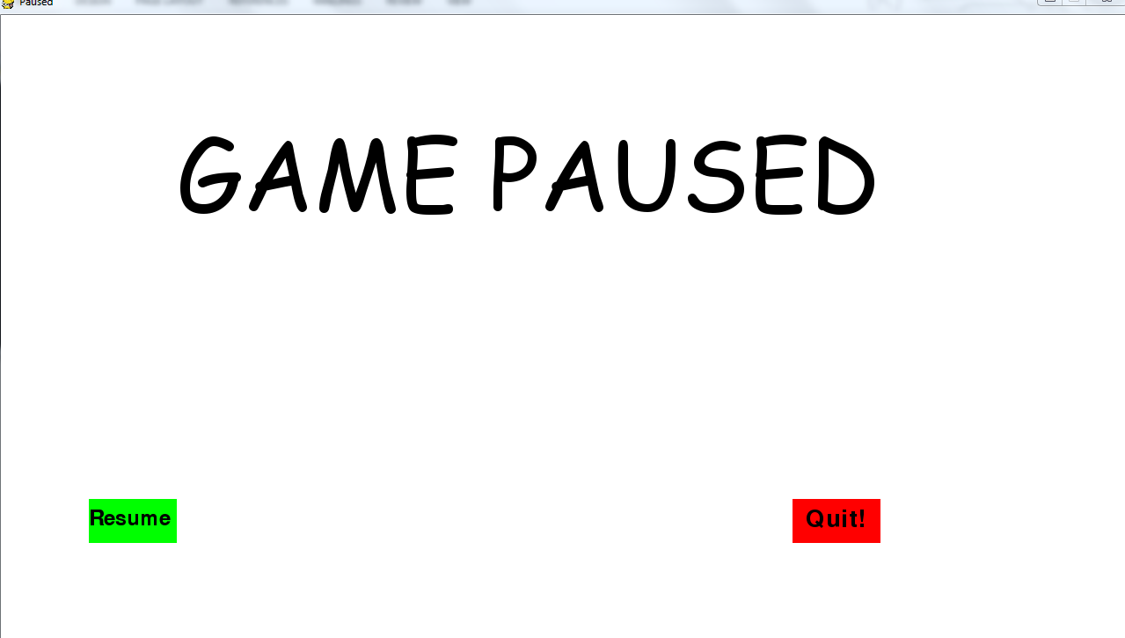

The goal is to eat as many apples as possible.

Every time an apple is eaten the snake will grow 1 in length. If the snake hits the side of the screen or hits it tail, you will die and the game will end.

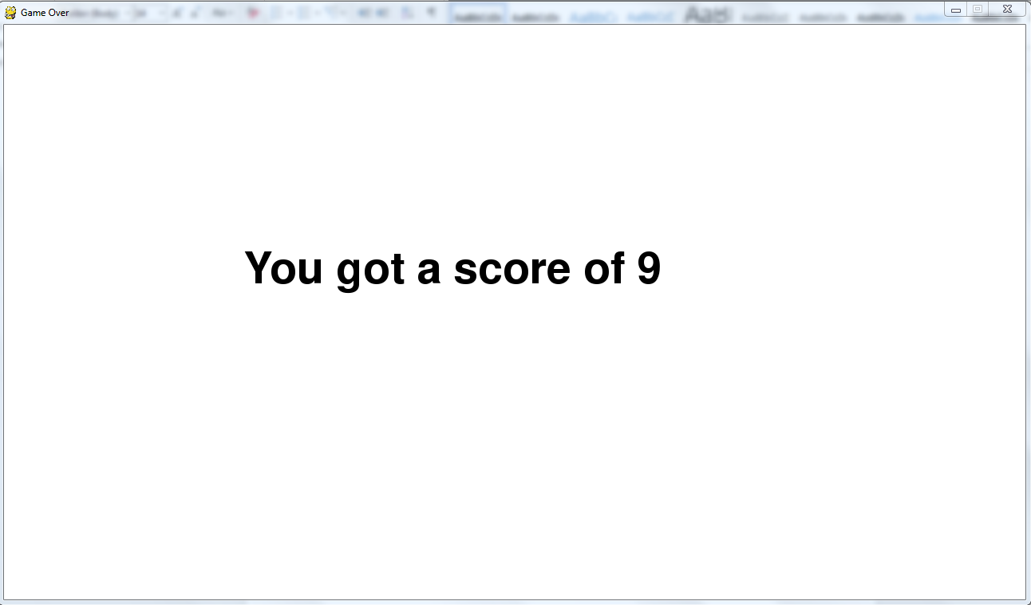You will then be taken to a gameover screen like this:

You may press the ENTER key to bring up a screen which will ask you if you would like to add your score to the leaderboards. That looks like this:

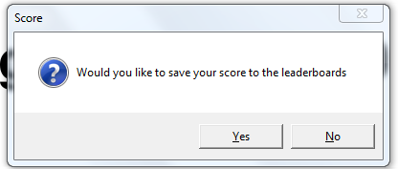

Clicking “Yes” will bring up a box to enter your name or a nickname. That box looks like this:



Enter your name in the white box and click enter to save your score to the leaderboard with you name or nickname.

If you accidentally close this box then make sure to close the tkinter window box:

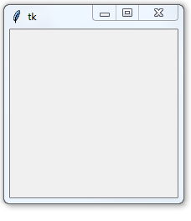

Then return to the window as normal and press enter key again to add the score to the leaderboard. Otherwise just ignore that box.

Then to return to the main menu just use the ESCAPE key as you can do from any screen.